Palash Bajpai

UML Class
Diagrams

Table of Contents
1. What is UML? 2
1. Types of UML 2
2. Understanding Class Diagrams 4
3. Basics of UML Class Diagrams 6
Class Representation 6
Attributes and methods 6
4. Relationships in Class Diagrams 8
1. Associations 8
2. Aggregation 10
3. Composition 11
4. Generalization (Inheritance) 12
5. Dependency 13
5. Advanced Class Diagram Concepts 15
Multiplicity 15
Interfaces and Abstract Classes 16
Enums 17
Association Class 17
Do’s and Don’ts of UML Class Diagram 18
6. UML Class Diagrams for Real-World Systems 19
UML Class Diagram for an E-commerce System 19
UML Class Diagram for Library Management 20
7. Interview Questions 21

1. What is UML?

Unified Modeling Language (UML) is a standardized visual modeling language used to design and document software systems. It helps developers, architects, and stakeholders understand and communicate the structure and behavior of a system
✔️ provides a standard way to visualize system architecture.
✔️ Supports object-oriented design (OOD).
✔️ Used for designing, analyzing, and documenting software systems.
✔️ Independent of programming languages and development methodologies.

Real World Example:
Imagine you are developing an E-commerce Application (like Amazon). UML helps visualize:
- How users interact with the system.
- How products, orders, and payments are related.
- How different components communicate.

1. Types of UML

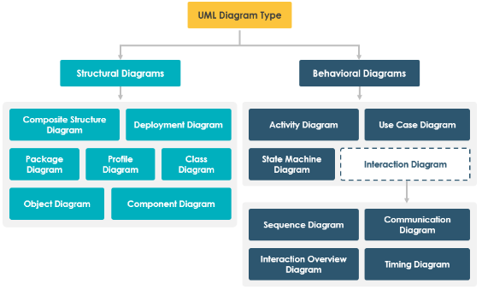
Structural Diagrams
These diagrams represent the static aspects of a system—how components are structured.

UML Diagram | Purpose | Example
Class Diagram | Defines object structure & relationships. | Customer has Orders in an e-commerce system.
Object Diagram | Represents instances of classes at a specific time. | A real-time snapshot of Order and its associated Product.
Component Diagram | Shows how components interact. | Payment module in a banking app.
Deployment Diagram | Represents hardware/software deployment. | AWS cloud infrastructure for a web app.
Package Diagram | Organizes related classes. | Organizing Customer, Order, and Product in different packages.

Behavioral Diagrams
These diagrams represent the dynamic aspects of a system—how components behave over time.
UML Diagram | Purpose | Example
Use Case Diagram | Defines user interactions with the system. | A Customer placing an Order.
Sequence Diagram | Shows message flow between objects. | User authentication in a login system.
Activity Diagram | Represents workflows & processes. | Steps in an online payment transaction.
State Diagram | Represents object states & transitions. | Order transitioning from Placed → Shipped → Delivered.

2. Understanding Class Diagrams

A Class Diagram is a UML diagram that represents the static structure of a system. It shows:
- Classes (objects) and their properties/methods.
- Relationships between classes (Association, Inheritance, etc.).
- Visibility (public, private, protected).✔️ provides a standard way to visualize system architecture.

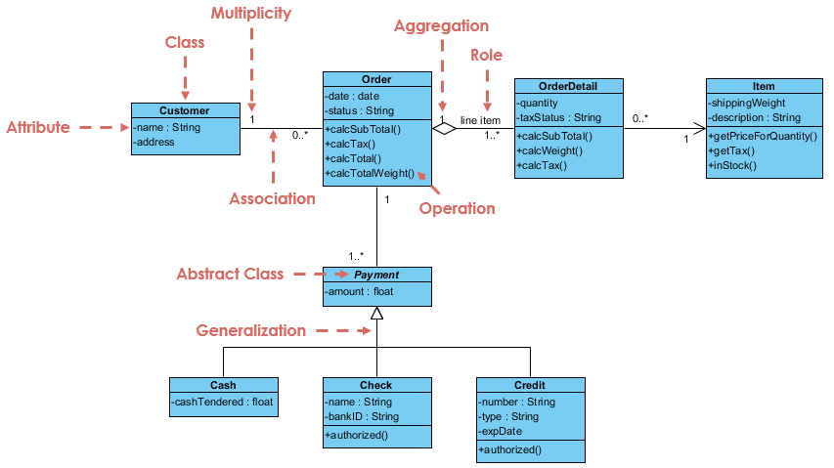

Role of Class Diagrams
- Blueprint of the System: Helps design object-oriented software before coding.
- Easy Communication: Developers, architects, and stakeholders understand relationships better.
- System Maintenance: Helps in debugging and extending functionalities.
- Reduces Complexity: Breaks large software into smaller, manageable parts..

Similarity with OOPs
Mapping of UML concepts to OOP
UML Concept | OOP Concept | Example
Class | Blueprint of objects | BankAccount, Customer, Order
Attributes | Class variables | balance in BankAccount
Methods | Functions in a class | withdraw(), deposit()
Association | Object relationship | Customer has multiple Orders
Generalization | Inheritance | AdminUser extends User
Composition | "Has-a" relationship | Car has an Engine

3. Basics of UML Class Diagrams

Class Representation

A Class in UML represents a blueprint for objects. It defines attributes (data) and methods (behavior).
A class in UML is depicted as a rectangle divided into three sections:
1️. Class Name (First Section)
2️. Attributes (Properties/Fields) (Second Section)
3️. Methods (Functions/Operations) (Third Section)

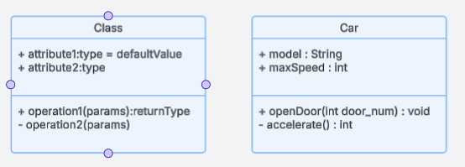

Attributes and methods

Attributes: Attributes define the state of a class (fields/variables).

Methods: Methods define behavior (actions).

Visibility: Visibility notations indicate the access level of attributes and methods.

Visibility | Symbol | Meaning
Public | + | Accessible by any class
Private | - | Only accessible within the class
Protected | # | Accessible by the class and subclasses
Static methods and attributes
Static Attributes: Belong to the class rather than an instance.
Static Methods: Operate at the class level rather than instance level.
Notation in UML:
- Static attributes are underlined in class diagrams.
- Static methods are underlined as well.
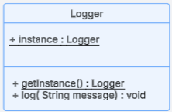

4. Relationships in Class Diagrams

In UML, relationships between classes define how objects of different classes interact. Understanding these relationships is crucial for object-oriented design and software modelling.

1. Associations

An Association represents a relationship between two or more classes where objects of one class are linked to objects of another class. It can be bidirectional or unidirectional.
Notation
- Solid Line (—) connects related classes.
- Arrow (→) for unidirectional associations.

Eg1: User can use car, but car can’t use user
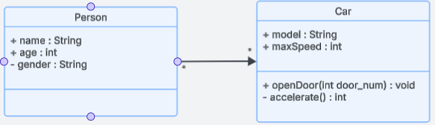

Multiple times we can even add uses on the connecting arrows
Eg2: Person drives the car
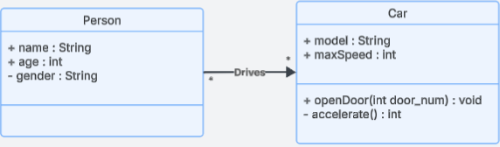

Types of Associations:
1️. One-to-One
2️. One-to-Many
3️. Many-to-Many

- One-to-One (1:1)
Each instance of Class A is related to exactly one instance of Class B.
Eg: A person can have exactly one Passport

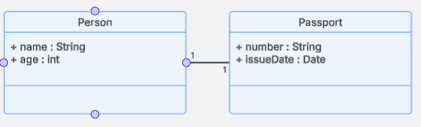

- One-to-Many (1:M)
One instance of Class A is related to multiple instance of Class B.
Eg: A department can have multiple students

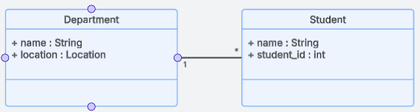

- Many-to-Many (1:M)
Multiple instance of Class A is related to multiple instance of Class B.
Eg: A Student can enrol in multiple Courses, and a Course can have multiple Students.

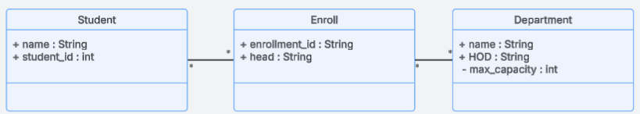

2. Aggregation

Both Aggregation and Composition represent “whole-part” relationships but differ in ownership strength.

Aggregation denotes a stronger relationship where one class (the whole) contains or is composed of another class (the part).
Key points
- Represents "Has-A" relationship
- Is a weaker relationship
- Child can exist independently of Parent
- Notation: Hollow Diamond (◊) at the whole

Eg: Person has a house, but house can exist independent from person
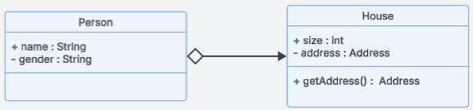

Aggregation is represented by a diamond shape on the side of the whole class. In this kind of relationship, the child class can exist independently of its parent class.
Eg 2: A Department (whole class) has multiple Employees, but Employees can exist independent of department too.

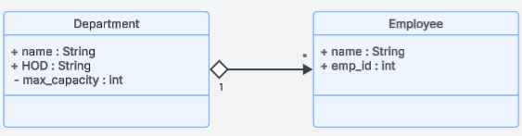

3. Composition

Composition is a stronger form of aggregation, indicating a more significant ownership or dependency relationship. In composition, the part class cannot exist independently of the whole class.
Key Points:
- Represents "Part-Of" relationship
- Child CANNOT exist without Parent
- Notation: Filled Diamond (◆) at the whole

Eg: A House has multiple Rooms, but a Room cannot exist without a House.
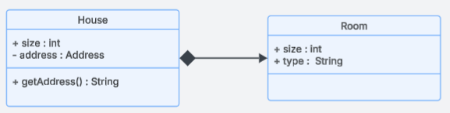

Key Differences:
Feature | Aggregation | Composition
Dependency | Child exists independently | Child cannot exist without Parent
Lifespan | Child’s life is independent | Child’s life depends on Parent
Example | Company & Employees | House & Rooms

4. Generalization (Inheritance)

It represents an "is-a" relationship between a parent class (superclass) and its child classes (subclasses). It models inheritance in object-oriented design, allowing the child classes to inherit attributes and behaviors from the parent class while also enabling specialization.
Key Points:
- Represents "IS-A" relationship (Parent-Child relationship).
- Superclasses (Parent) define common attributes and methods.
- Subclasses (Child) inherit these features.
- Notation: Arrow (▲) pointing to Superclass

Eg: Vehicle -> Car, bike
- Car and Bike inherit Vehicle properties (brand, speed, move()).
- Car has its own method drive(), and Bike has ride().

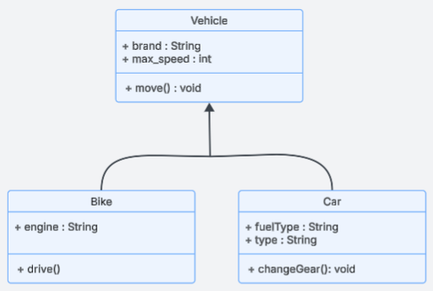

5. Dependency

It represents a weak relationship between two classes where one class depends on another temporarily. It signifies that a change in one class may impact the other, but they do not have a strong association like inheritance (generalization) or composition.
Key Points:
- It is a one-way relationship where one class relies on another for its functionality.
- It is represented by a dashed arrow pointing from the dependent class to the independent class.
- The dependent class uses the other class but does not own it permanently.

Eg: An ATM class depends on a BankAPI class to retrieve account details and process transactions.
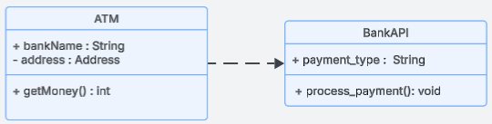

Types of Dependency:
- Parameter Dependency: A class depends on another when an object of one class is passed as a parameter.
class Order {
void processPayment(Payment payment) {
payment.pay();
}
}
Here, Order depends on Payment but does not store it permanently.

- Return Type Dependency: A method returns an object of another class.
class UserRepository {
User getUser(int id) {
return new User(id, "John");
}
}
- Local Variable Dependency : A method creates and uses an instance of another class.
class Order {
void process() {
Payment payment = new Payment();
payment.pay();
}
}

- Exception Dependency: A class depends on another when it throws an exception of that class type.
class Database {
void connect() throws SQLException {
// Code to connect to DB
}
}

5. Advanced Class Diagram Concepts

Multiplicity

Multiplicity in UML defines how many instances of a class can be associated with an instance of another class. It helps in defining cardinality constraints in relationships between objects in a UML class diagram.

Key concepts:
- Specifies the number of instances that can participate in a relationship.
- Expressed as ranges (e.g., 1..* means at least 1 and unlimited maximum).
- Used in association, aggregation, and composition relationships.

Notation | Meaning
1 | Exactly one instance
0..1 | Zero or one instance (optional)
* or 0..* | Zero or more instances (unlimited)
1..* | At least one instance (one or more)
n | Exactly n instances
m..n | Between m and n instances

Eg: A Library can have multiple Books
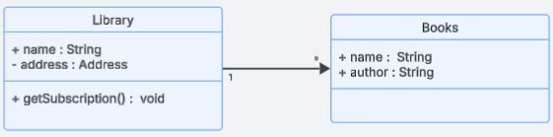

Interfaces and Abstract Classes

Feature | Abstract Class | Interface
Definition | A class that cannot be instantiated and may contain both abstract and concrete methods. | A contract that contains only method declarations (no implementation).
Purpose | Provides partial implementation for subclasses. | Defines a standard set of methods that different classes must implement.
Methods | Can have both abstract and non-abstract methods. | Only abstract methods (default in Java 7 and earlier).
Variables | Can have instance variables. | Variables are public, static, and final by default.
Constructors | Can have a constructor. | Cannot have a constructor.
Multiple Inheritance | Supports single inheritance (A class can extend only one abstract class). | Supports multiple inheritance (A class can implement multiple interfaces).
UML Representation | Italicized class name with a stereotype <<abstract>>. | Italicized class name with a stereotype <<interface>>.

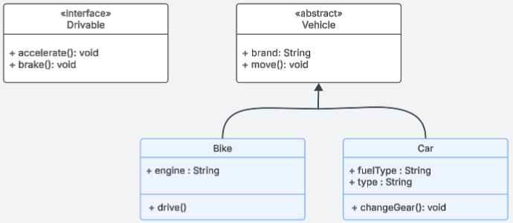

Enums

Enums define a fixed set of values that a variable can take.
Used when a property has limited predefined values.
Notation in UML:
- Enum classes use <<enumeration>>.
- Enum values are listed inside the class.
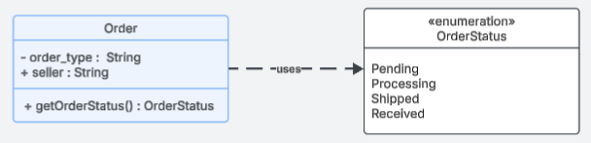

Association Class
Used when a relationship itself has attributes.
Represents a relationship as a separate entity.
When a relationship itself carries important data.
Notation in UML: A dashed line box between two related classes.
Eg: A Student enrolls in a Course. The Enrollment relationship has attributes like Grade, Enrollment Date.
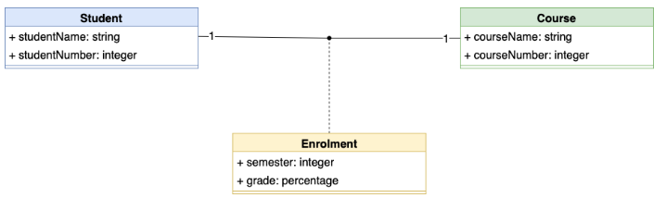

Do’s and Don’ts of UML Class Diagram

Do’s
- Use meaningful class names
- Use Inheritance when necessary
- Keep diagram readable and organized
- Instead of one massive diagram, split it into multiple diagrams according to usecase
  - Core Business Objects (e.g., User, Order, Payment).
  - Subsystems (e.g., Shipping, Inventory, Security).
  - Microservices Interaction Diagrams (for distributed architectures).
- Use Color Coding and Legend for Large Diagrams

Don’ts
- Don’t add unnecessary methods and attributes
- Don’t add too many classes in one diagram

6. UML Class Diagrams for Real-World Systems

UML Class Diagram for an E-commerce System
Classes & Relationships:
- User: Can place multiple Orders.
- Order: Contains multiple Products and is associated with a Payment.
- Product: Can be part of multiple Orders.
- Payment: Associated with one Order.

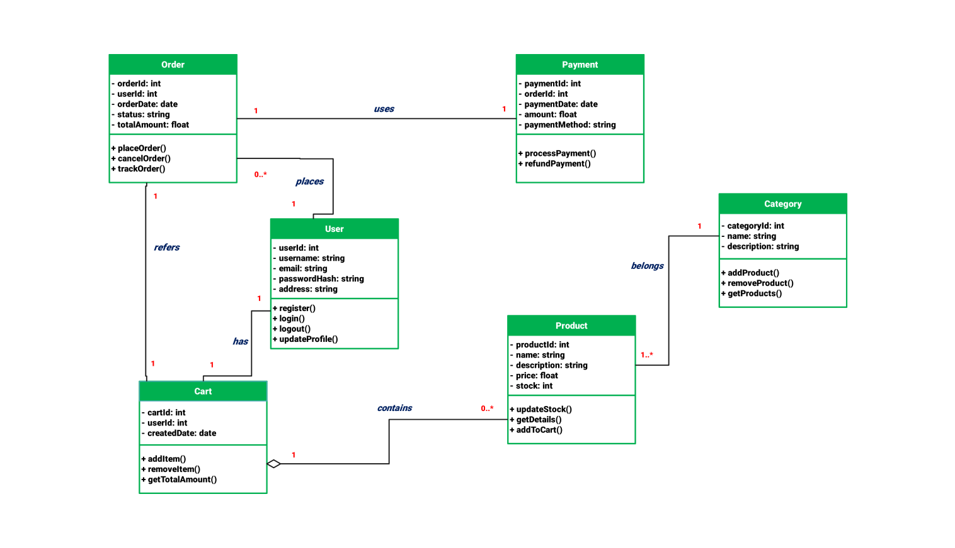

UML Class Diagram for Library Management

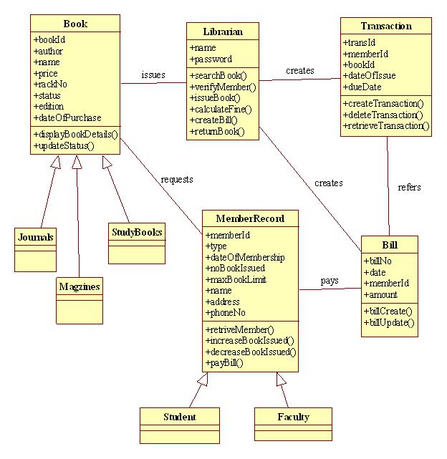

7. Interview Questions

Q1. How to check from code, which type of relationship it is?

Association means a "has-a" relationship where one class has a reference to another. Depending on how objects are stored and managed, association can be simple association, aggregation, or composition.
If an object is stored as a field in a class, it forms an association (———> in UML).
- Created separately & passed = Association
- Created separately & shared = Aggregation
- Created inside & destroyed together = Composition

- Simple Association (Solid Line → ———> in UML)
In a simple association, one class holds a reference to another, but neither controls the other’s lifecycle.
class Car {
private Engine engine; // Association: Car has an Engine
public Car(Engine engine) {
this.engine = engine;
}
public void start() {
System.out.println("Car is starting...");
engine.run();
}
}
class Engine {
public void run() {
System.out.println("Engine is running...");
}
}
public class Main {
public static void main(String[] args) {
Engine engine = new Engine(); // Engine created separately
Car car = new Car(engine); // Passing engine to Car
car.start();
}
}
2. Aggregation (Hollow Diamond ◇ → ◇———> in UML)
Aggregation means "has-a" but with shared ownership—the contained object (Engine) can exist independently of the owner (Car).

class Car {
private Engine engine; // Aggregation (Car has an Engine)
public Car(Engine engine) {
this.engine = engine;
}
public void start() {
System.out.println("Car is starting...");
engine.run();
}
}
class Engine {
public void run() {
System.out.println("Engine is running...");
}
}
public class Main {
public static void main(String[] args) {
// Engine created independently
Engine sharedEngine = new Engine();

// Shared engine in multiple cars
Car car1 = new Car(sharedEngine);
Car car2 = new Car(sharedEngine);
car1.start();
car2.start();
}
}

3. Composition (Filled Diamond ◆ → ◆———> in UML)
Composition means "strong ownership"—the contained object (Engine) cannot exist without the owner (Car). The Engine is created inside Car, and when Car is destroyed, Engine is also destroyed.

class Car {
private Engine engine; // Composition (Car has an Engine)
public Car() {
this.engine = new Engine();
}
public void start() {
System.out.println("Car is starting...");
engine.run();
}
}
class Engine {
public void run() {
System.out.println("Engine is running...");
}
}
public class Main {
public static void main(String[] args) {
Car car1 = new Car();
car1.start();
}
}

Q2. What type of relationship is present if object is created on runtime?

Yes, if an object is created at runtime but not stored as a field (attribute) in the class, it represents a dependency in UML.
Why is it a Dependency?
- The class relies on another class to create and use an object, but it does not own it permanently.
- The object exists temporarily in a method and is not retained as a part of the class’s structure.
- This is represented in UML as a dashed arrow (------>) (Dependency).
Code Eg:
class Client {
void execute() {
LuxuryHomeFactory factory = new LuxuryHomeFactory(); // Created at runtime
SmartHomeSystem system = new SmartHomeSystem(factory); // Created at runtime
system.activateHome();
}
}

When Is It NOT a Dependency?
If the object is stored as a field (attribute) in the class, it is association (solid line) and can be:
- Aggregation (hollow diamond ◇) → If the object can exist independently.
- Composition (filled diamond ◆) → If the object’s lifecycle is tied to the owner.

Q3. Is it necessary that an attribute of object, which is created inside a constructor of main object has Composition relationship between them
No, it only happens when object creation is handle by same class.

Code example:
class SmartHomeSystem {
private final SmartLight light;
private final SmartDoorLock doorLock;
public SmartHomeSystem(SmartHomeFactory factory) {
this.light = factory.createLight();
this.doorLock = factory.createDoorLock();
}
public void activateHome() {
System.out.println("Activating Smart Home...");
light.turnOn();
doorLock.lock();
}
}

Object of smartLight and SmartDoorLock is created inside a SmartHomeSystem, but relationship between them is dependency and not composition.
Composition (◆———>) means the contained objects (SmartLight, SmartThermostat, SmartDoorLock) must be created inside the class AND be destroyed with it.
However, in this code:
- The SmartHomeSystem does not create the objects directly—it gets them from SmartHomeFactory.
- The objects can exist independently of SmartHomeSystem (Factory is responsible for their creation).
- If SmartHomeSystem is destroyed, these objects may still exist (Factory creates them, so ownership is not exclusive).

When it will be composition:
If the objects were created inside SmartHomeSystem without an external factory:
class SmartHomeSystem {
private final SmartLight light;
private final SmartDoorLock doorLock;
public SmartHomeSystem() { // Objects created inside
this.light = new SmartLight();
this.doorLock = new SmartDoorLock();
}
public void activateHome() {
System.out.println("Activating Smart Home...");
doorLock.lock();
}
}

